**Module 3 – Exercise**

The goal of this exercise is to use the various elements of the Twitter Bootstrap framework to make a webpage

* Start with the given webpage – index.html.
* 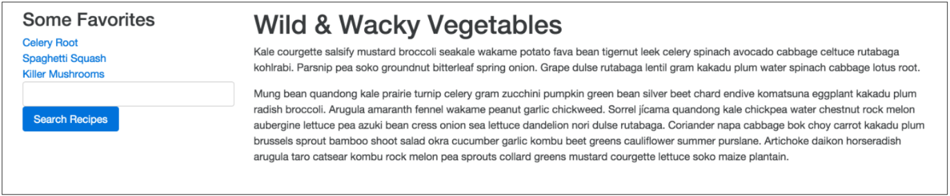Use the Bootstrap grids classes to create this webpage with a sidebar and main content:
* 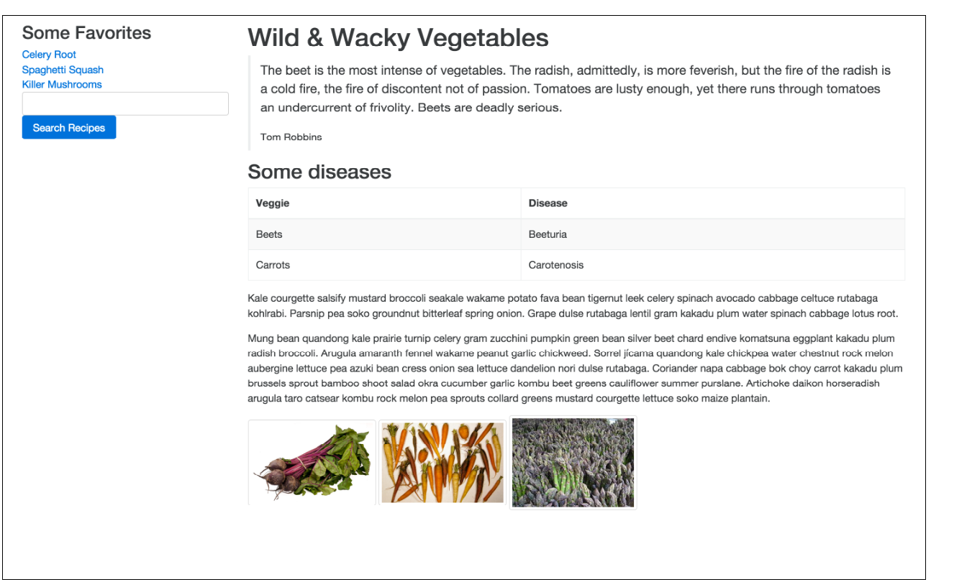Use the Bootstrap content CSS classes to add a quote, table, and image thumbnails to the page
* Use the Bootstrap components classes to add an alert, search form to the page.
* Also turn the sidebar list into a nav element, displayed as stacked pills.
* Display the images as a card group.

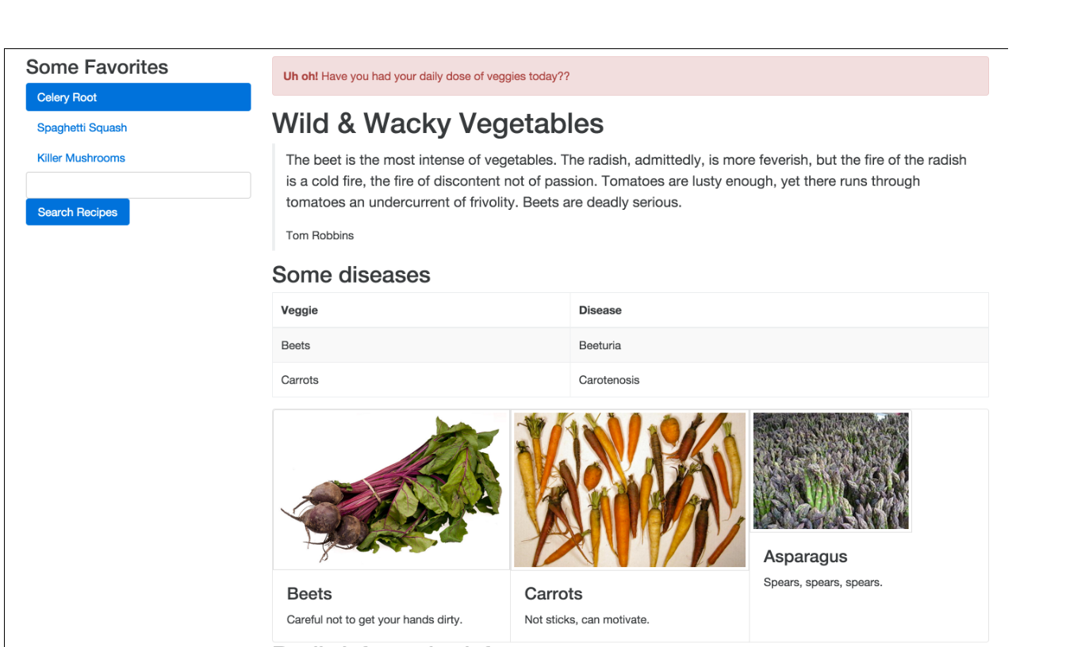

********************

END OF EXERCISE